**Assignment No . 1**

**Subject :**

**C Sharp( C# )**

**Topic :**

**Simple Calculator**

**Class :**

**MCS EVENING B**

**Roll .No :**

**SP20M2MB037**

**Submitted By:**

**Muhammad Saeed**

**Submitted To :**

**Sir Rehan Faheem sb**

**Simple Calculator**

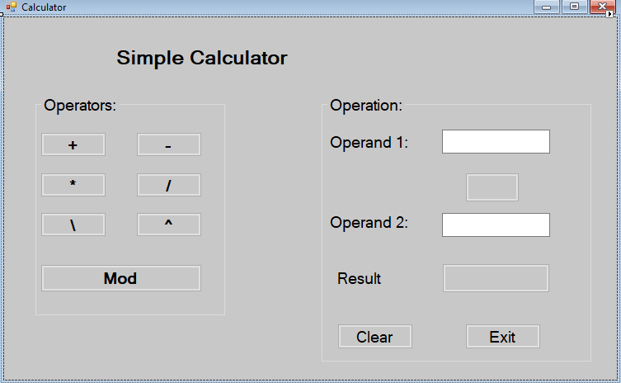

**Coding Behind The Form**

public partial class Calculator : Form

{

public Calculator()

{

InitializeComponent();

}

private void label1_Click(object sender, EventArgs e)

{

}

private void button11_Click(object sender, EventArgs e)

{

Application.Exit();

}

private void button1_Click(object sender, EventArgs e)

{

button9.Text = Convert.ToString(Convert.ToInt32(textBox1.Text) + Convert.ToInt32(textBox2.Text));

}

private void button10_Click(object sender, EventArgs e)

{

textBox1.Clear();

textBox2.Clear();

button9.Text = "";

}

private void button2_Click(object sender, EventArgs e)

{

button9.Text = Convert.ToString(Convert.ToInt32(textBox1.Text) - Convert.ToInt32(textBox2.Text));

}

private void button3_Click(object sender, EventArgs e)

{

button9.Text = Convert.ToString(Convert.ToInt32(textBox1.Text) * Convert.ToInt32(textBox2.Text));

}

private void button4_Click(object sender, EventArgs e)

{

button9.Text = Convert.ToString(Convert.ToInt32(textBox1.Text) / Convert.ToInt32(textBox2.Text));

}

private void button6_Click(object sender, EventArgs e)

{

button9.Text = Convert.ToString(Math.Pow(Convert.ToInt32(textBox1.Text), Convert.ToInt32(textBox2.Text)));

}

private void button7_Click(object sender, EventArgs e)

{

button9.Text = Convert.ToString(Convert.ToInt32(textBox1.Text) % Convert.ToInt32(textBox2.Text));

}

private void textBox1_TextChanged(object sender, EventArgs e)

{

textBox1.Focus();

}

}

}